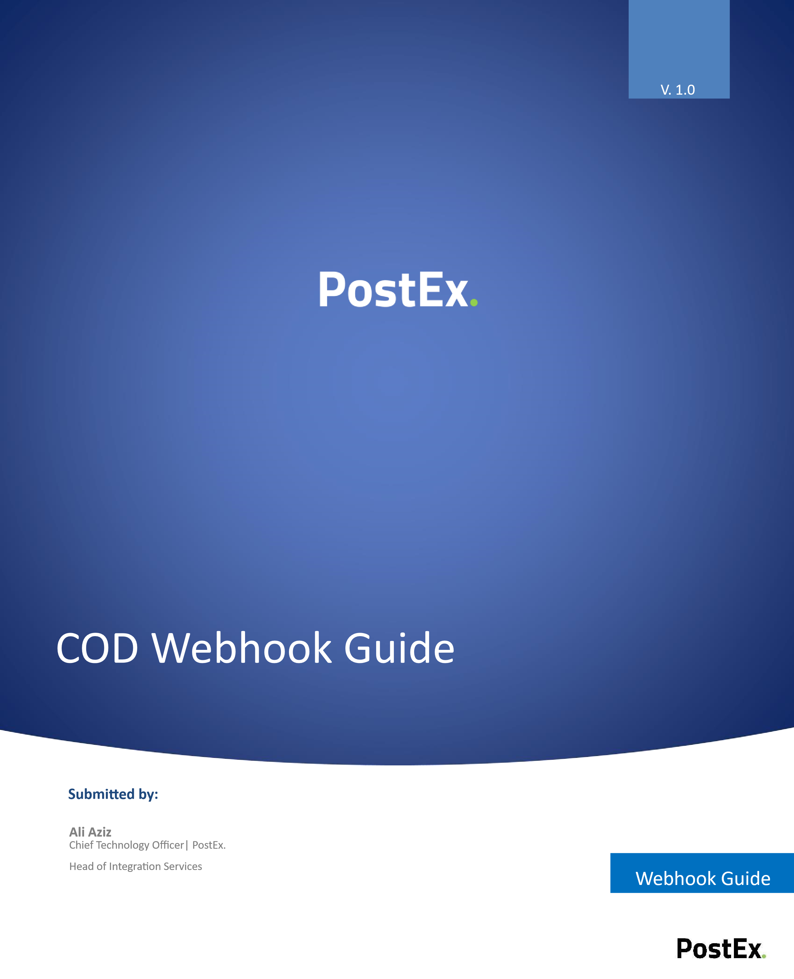
Contact: ali@postexglobal.com
Contents
1. What is a Webhook? 2
2. How to Integrate the Webhook 3
3. Order Status Updates 4
3.2. Parameters 4
3.3. Request Parameters 6

What is a Webhook?
A PostEx webhook is a feature where PostEx automatically sends order updates to the merchant’s system whenever something changes in an order.
Instead of the merchant repeatedly checking the PostEx portal or calling an API, PostEx pushes the update itself.

How to Integrate the Webhook
(Step by Step)
- Login into the PostEx Merchant Portal

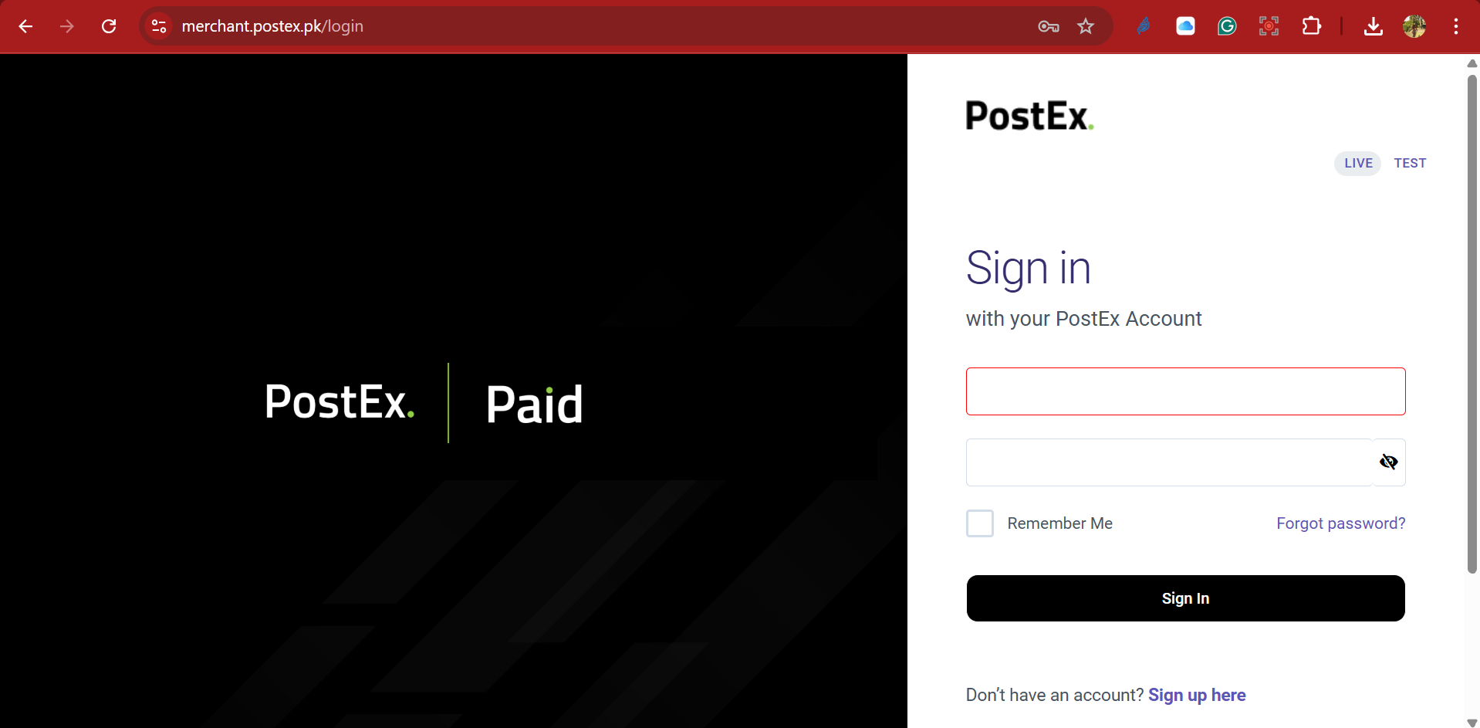

- In the Settings menu, go to the Developer’s Guide option.

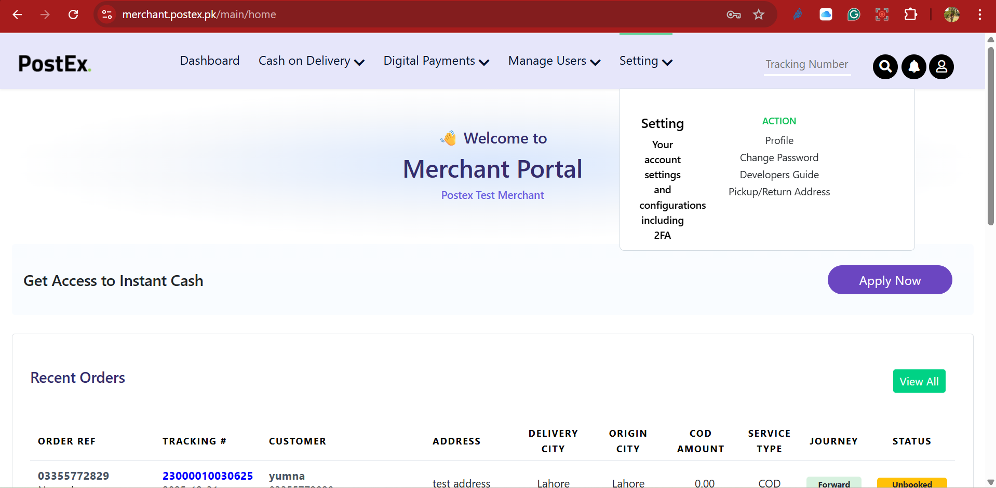

- The merchant will create a webhook API URL and provide it to PostEx by adding it in the Status Updates Webhook field.
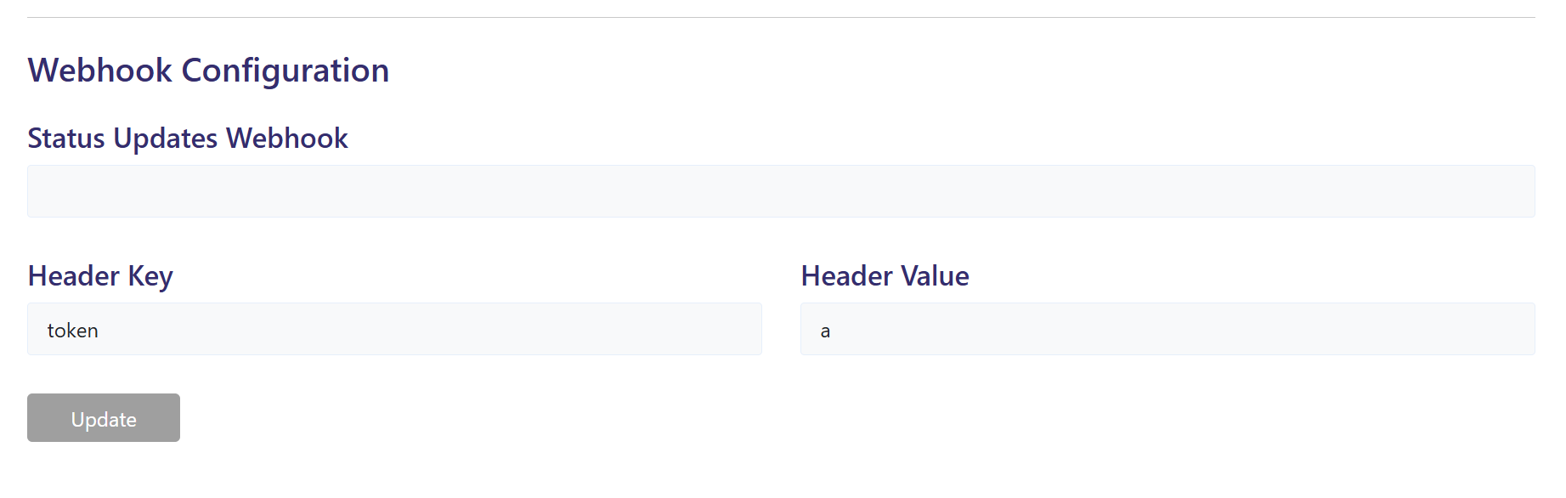

- If authorization is required, add the necessary Header and Token values.

- Press on the update


Order Status Updates

3.2. Parameters
Parameter | Explanation | Data Type
trackingNumber | A Unique number to identify any booking in PostEx system. i.e., “2XXXXXXXXXXXXX” | String
orderReferenceNumber | An order number to identify any order in Merchant system. | String
statusUpdateDatetime | The date & time when the latest update is completed. | String
orderStatus | A unique string which represents current status of any parcel in PostEx system.  The following are the possible values  Unbooked  Booked  PostEx WareHouse  Out For Delivery  Delivered  Returned  Un-Assigned By Me  Expired  Delivery Under Review  Picked By PostEx  Out For Return  Attempted  En-Route to {city} warehouse | String
returnRequested | A boolean flag that indicates whether the shipment is in forward delivery or has entered the return journey.  - false → Order is still in the forward journey (going to customer)  - true → Order has moved to the return journey (coming back to shipper)

3.3. Request Parameters

{

"trackingNumber":"string",
"orderReferenceNumber":"string",
"statusUpdateDatetime":"string",
"orderStatus":"string" ,
“returnRequested”: “boolean”
}
Note: Please feel free to write at support@postex.pk in case of any query(s).

